Four Day Cricket
Season | M | Inns | NO | HS | Runs | Balls | Ave | S/R | 100 | 50 | Cts | Sts | Balls | Mdns | Runs | Wkts | Ave | Best | 5W/I | 10W/M | R/O | R/100B | S/R
1993/94 | 88 | 119 | 17 | 140 | 3139 | 8079 | 30.77 | 38.85 | 7 | 15 | 70 | 3 | 8039 | 430 | 3019 | 134 | 22.5 | 6/30 | 4 | 1 | 2.25 | 37.55 | 59.99
1994/95 | 77 | 132 | 18 | 191 | 3534 | 7363 | 31.00 | 48.00 | 6 | 20 | 51 | 2 | 7461 | 322 | 3490 | 105 | 33.24 | 7/57 | 3 | 1 | 2.81 | 46.78 | 71.06
1995/96 | 55 | 106 | 11 | 125 | 1970 | 4576 | 20.74 | 43.05 | 1 | 9 | 34 |  | 4743 | 195 | 2186 | 58 | 37.69 | 6/93 | 1 |  | 2.77 | 46.09 | 81.78
1996/97 | 91 | 117 | 16 | 251* | 4007 | 8448 | 39.67 | 47.43 | 9 | 16 | 77 | 1 | 8695 | 420 | 3644 | 137 | 26.60 | 6/22 | 6 | 1 | 2.51 | 41.91 | 63.47
1997/98 | 79 | 117 | 14 | 95 | 2736 | 5685 | 26.56 | 48.13 | 0 | 18 | 66 |  | 6714 | 328 | 2740 | 111 | 24.68 | 6/35 | 3 | 1 | 2.45 | 40.81 | 60.49
1998/99 | 55 | 90 | 13 | 187 | 1922 | 4889 | 24.96 | 39.31 | 2 | 10 | 35 | 1 | 3683 | 177 | 1751 | 63 | 27.79 | 5/44 | 2 |  | 2.85 | 47.54 | 58.46
1999/00 | 55 | 102 | 12 | 125 | 2317 | 6096 | 25.74 | 38.01 | 1 | 14 | 40 | 2 | 4978 | 204 | 2288 | 65 | 35.20 | 5/84 | 1 |  | 2.76 | 45.96 | 76.58
2000/01 | 121 | 202 | 30 | 172 | 5157 | 12555 | 29.98 | 41.08 | 8 | 28 | 75 |  | 9440 | 406 | 4699 | 111 | 42.33 | 7/151 | 3 |  | 2.99 | 49.78 | 85.05
2001/02 | 121 | 199 | 28 | 158* | 4549 | 11075 | 26.60 | 41.07 | 6 | 26 | 85 | 3 | 10204 | 445 | 4577 | 159 | 28.79 | 7/53 | 5 | 1 | 2.69 | 44.85 | 64.18
2002/03 | 114 | 167 | 21 | 301* | 4544 | 9977 | 31.12 | 45.54 | 6 | 20 | 74 | 2 | 10393 | 437 | 4953 | 140 | 35.38 | 5/69 | 2 |  | 2.86 | 47.66 | 74.24
2003/04 | 99 | 155 | 24 | 192 | 3892 | 8461 | 29.71 | 43.30 | 7 | 17 | 83 | 2 | 8758 | 408 | 3747 | 139 | 26.96 | 5/35 | 6 |  | 2.57 | 42.78 | 63.01
2004/05 | 88 | 135 | 16 | 221* | 3368 | 6498 | 28.30 | 51.83 | 6 | 12 | 77 |  | 6626 | 269 | 3254 | 125 | 26.03 | 9/13 | 4 | 2 | 2.95 | 49.11 | 53.01
2005/06 | 88 | 132 | 18 | 119* | 3278 | 7321 | 28.75 | 44.78 | 4 | 19 | 62 | 1 | 6622 | 285 | 3406 | 101 | 33.72 | 5/82 | 1 |  | 3.09 | 51.43 | 65.56
2006/07 | 99 | 136 | 24 | 188 | 4658 | 9658 | 41.59 | 48.23 | 11 | 21 | 77 | 1 | 9999 | 392 | 4997 | 115 | 43.45 | 5/37 | 2 |  | 3.00 | 49.97 | 86.95
2007/08 | 99 | 152 | 29 | 148* | 4126 | 8463 | 33.54 | 48.75 | 6 | 24 | 84 |  | 9189 | 353 | 4451 | 136 | 32.73 | 7/50 | 4 | 1 | 2.91 | 48.44 | 67.56

Centuries scored to balls faced
0
2000
4000
6000
93/94
95/96
97/98
99/00
01/02
03/04
05/06
07/08
Fifities scored to balls faced
200
300
400
500
600
93/94
95/96
97/98
99/00
01/02
03/04
05/06
07/08
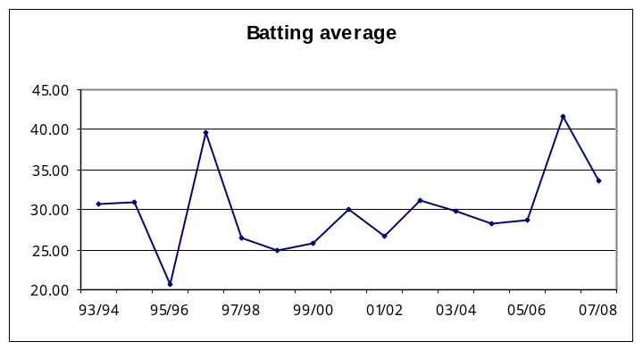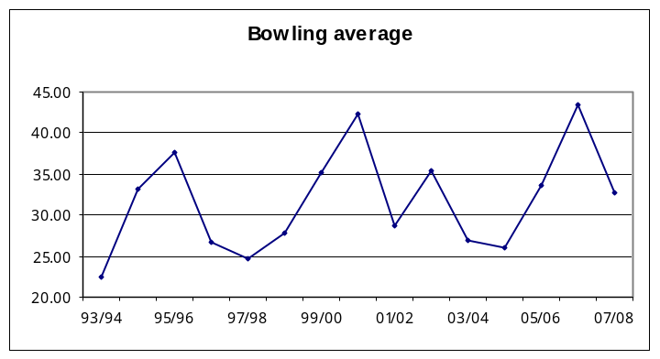

Runs per over batted
2.20
2.40
2.60
2.80
3.00
3.20
93/94
95/96
97/98
99/00
01/02
03/04
05/06
07/08
Runs per over bowled
2.00
2.20
2.40
2.60
2.80
3.00
3.20
93/94
95/96
97/98
99/00
01/02
03/04
05/06
07/08

